
ADICIONES Y SUSTRACCIONES

Adiciones reagrupando
* Resuelve las siguientes adiciones:
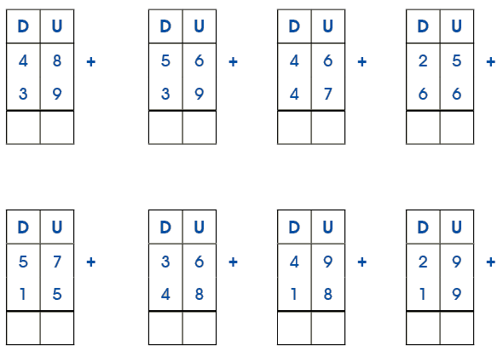


Seguimos practicando
* Resuelve las siguientes adiciones:
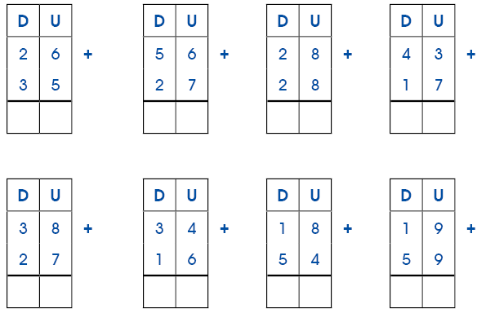
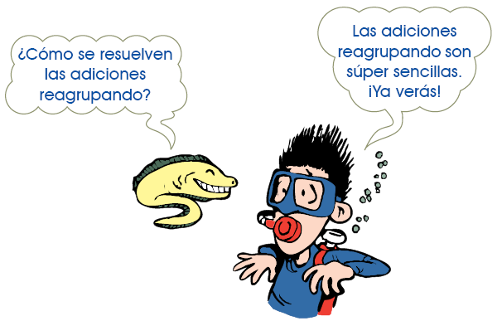

Resolvemos restas
* Resuelve las siguientes sustracciones:

D | U |  |  | D | U |  |  | D | U |  |  | D | U
9 | 8 | - |  | 5 | 1 | - |  | 7 | 6 | - |  | 7 | 5 | -
6 | 1 |  |  | 1 | 0 |  |  | 7 | 3 |  |  | 2 | 3
D | U |  |  | D | U |  |  | D | U |  |  | D | U
8 | 7 | - |  | 9 | 6 | - |  | 3 | 8 | - |  | 7 | 8 | -
2 | 0 |  |  | 9 | 6 |  |  | 2 | 8 |  |  | 2 | 7


Seguimos practicando
* Resuelve las siguientes sustracciones:

D | U |  |  | D | U |  |  | D | U |  |  | D | U
5 | 9 | - |  | 7 | 8 | - |  | 8 | 1 | - |  | 7 | 2 | -
2 | 2 |  |  | 1 | 3 |  |  | 6 | 0 |  |  | 1 | 0
D | U |  |  | D | U |  |  | D | U |  |  | D | U
5 | 6 | - |  | 6 | 9 | - |  | 7 | 5 | - |  | 7 | 8 | -
1 | 1 |  |  | 6 | 9 |  |  | 3 | 4 |  |  | 1 | 4



Restas diferentes
* Resuelve con atención las siguientes restas:

D | U |  |  | D | U |  |  | D | U |  |  | D | U
5 | 3 | - |  | 5 | 6 | - |  | 4 | 4 | - |  | 5 | 5 | -
1 | 8 |  |  | 2 | 9 |  |  | 2 | 6 |  |  | 2 | 9
D | U |  |  | D | U |  |  | D | U |  |  | D | U
3 | 1 | - |  | 2 | 4 | - |  | 5 | 1 | - |  | 7 | 2 | -
1 | 5 |  |  | 1 | 7 |  |  | 3 | 8 |  |  | 4 | 8



Seguimos practicando
* Resuelve las siguientes restas:
D | U |  |  | D | U |  |  | D | U |  |  | D | U
7 | 2 | - |  | 6 | 2 | - |  | 8 | 3 | - |  | 6 | 2 | -
3 | 5 |  |  | 4 | 4 |  |  | 6 | 5 |  |  | 3 | 9
D | U |  |  | D | U |  |  | D | U |  |  | D | U
4 | 2 | - |  | 5 | 5 | - |  | 6 | 3 | - |  | 7 | 3 | -
1 | 9 |  |  | 2 | 7 |  |  | 3 | 6 |  |  | 4 | 7


¡A restar!
* Resuelve las siguientes sustracciones:
D | U |  |  | D | U |  |  | D | U |  |  | D | U
7 | 2 | - |  | 6 | 2 | - |  | 8 | 3 | - |  | 6 | 2 | -
3 | 5 |  |  | 4 | 4 |  |  | 6 | 5 |  |  | 3 | 9
D | U |  |  | D | U |  |  | D | U |  |  | D | U
4 | 2 | - |  | 5 | 5 | - |  | 6 | 3 | - |  | 7 | 3 | -
1 | 9 |  |  | 2 | 7 |  |  | 3 | 6 |  |  | 4 | 7
D | U |  |  | D | U |  |  | D | U |  |  | D | U
9 | 0 | - |  | 8 | 5 | - |  | 2 | 3 | - |  | 9 | 5 | -
5 | 7 |  |  | 3 | 6 |  |  |  | 7 |  |  | 1 | 8

¡Seguimos restando!
2. Resuelve las siguientes restas:
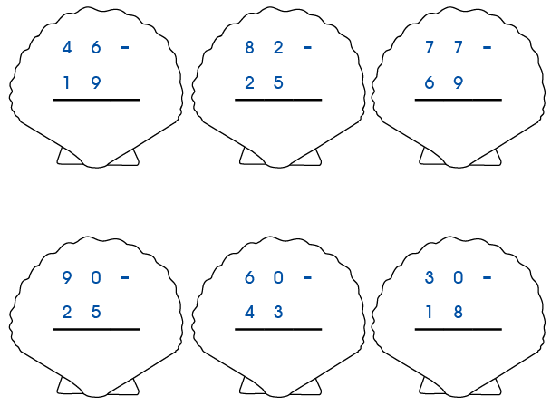
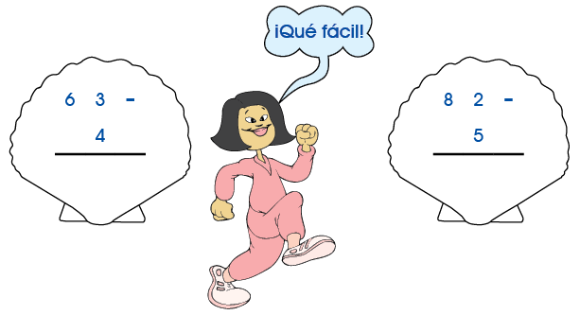

Adiciones y sustracciones
1. Resuelve las siguientes adiciones y sustracciones:
D | U |  |  | D | U |  |  | D | U |  |  | D | U
2 | 3 | + |  | 1 | 5 | + |  | 2 | 7 | + |  | 4 | 3 | +
1 | 8 |  |  | 4 | 5 |  |  |  | 9 |  |  | 3 | 4
D | U |  |  | D | U |  |  | D | U |  |  | D | U
6 | 6 | - |  | 4 | 0 | - |  | 2 | 2 | - |  | 5 | 7 | -
2 | 9 |  |  | 1 | 7 |  |  | 1 | 8 |  |  | 2 | 9



Seguimos practicando
1. Resuelve las siguientes operaciones:
D | U |  |  | D | U |  |  | D | U |  |  | D | U
1 | 2 | + |  | 2 | 5 | + |  |  | 6 | + |  | 4 | 1 | +
2 | 7 |  |  |  | 2 |  |  | 1 | 3 |  |  |  | 7
2 | 7 |  |  | 2 | 5 |  |  |  | 7 |  |  |  | 5
D | U |  |  | D | U |  |  | D | U |  |  | D | U
4 | 4 | - |  | 2 | 5 | - |  | 6 | 2 | - |  | 3 | 3 | -
1 | 6 |  |  |  | 7 |  |  |  | 9 |  |  | 2 | 9
D | U |  |  | D | U |  |  | D | U |  |  | D | U
2 | 7 | + |  | 7 | 0 | + |  | 4 | 5 | + |  | 5 | 5 | +
3 | 5 |  |  | 2 | 8 |  |  | 3 | 9 |  |  | 1 | 7

Adiciones y sustracciones
1. Resuelve con mucha atención:
D | U |  |  | D | U |  |  | D | U |  |  | D | U
8 | 8 | - |  |  | 7 | + |  | 7 | 1 | - |  | 5 | 1 | +
5 | 9 |  |  | 5 | 5 |  |  | 3 | 6 |  |  |  | 7
 |  |  |  | 3 | 9 |  |  |  |  |  |  | 1 | 9
D | U |  |  |  |  |  |  | D | U
2 | 4 | + |  | D | U |  |  | 3 | 3 | + |  | D | U
1 | 4 |  |  | 7 | 1 | - |  | 4 | 9 |  |  | 8 | 4 | -
2 | 9 |  |  | 2 | 7 |  |  | 1 | 7 |  |  | 5 | 5
D | U |  |  | D | U |  |  | D | U |  |  | D | U
2 | 4 | - |  | 3 | 9 | - |  | 4 | 5 | - |  | 7 | 8 | -
1 | 7 |  |  | 2 | 9 |  |  | 3 | 3 |  |  | 3 | 9
D | U |  |  | D | U |  |  | D | U |  |  | D | U
8 | 1 | - |  | 4 | 2 | - |  | 8 | 7 | + |  | 7 | 1 | +
1 | 8 |  |  | 1 | 5 |  |  | 5 | 9 |  |  | 3 | 9

D | U |  |  | D | U |  |  | D | U |  |  | D | U
3 | 6 | + |  | 1 | 8 | + |  | 6 | 1 | - |  | 9 | 0 | -
1 | 9 |  |  | 1 | 8 |  |  | 4 | 6 |  |  | 4 | 5
1 | 9 |  |  | 2 | 8

